**Junyi academy online learning activity**

Present by:

Mohammadmahdi heydari asl

Seyedesadegh elmi Mousavi

Seyedehsara hashemi

**About dataset**

The importance and popularity of online learning have increased a lot as the world is moving into an information era. The current COVID-19 situation shows that online learning acts both as a promising medium for equitable quality education, and an essential component for the education system when campuses shut down.

The dataset has information about the time each student spent on website, their level and grade , if they are self studied or not and so on.

We work on the time that each student spend on website that we discuss about it in further.

**Data description**

Dataset is provided by three tables.

Log_Problem.csv: recorded 16,217,311 problem attempts of 72,630 selected students for a year from 2018/08 to 2019/07.

Info_Content.csv: describes the metadata of the exercises, each exercise is a basic unit of learning consisted of many problems.

Info_UserData.csv: describes the metadata of the selected registered students in Junyi Academy.

The head of each table is shown below:

**Log_problem:**

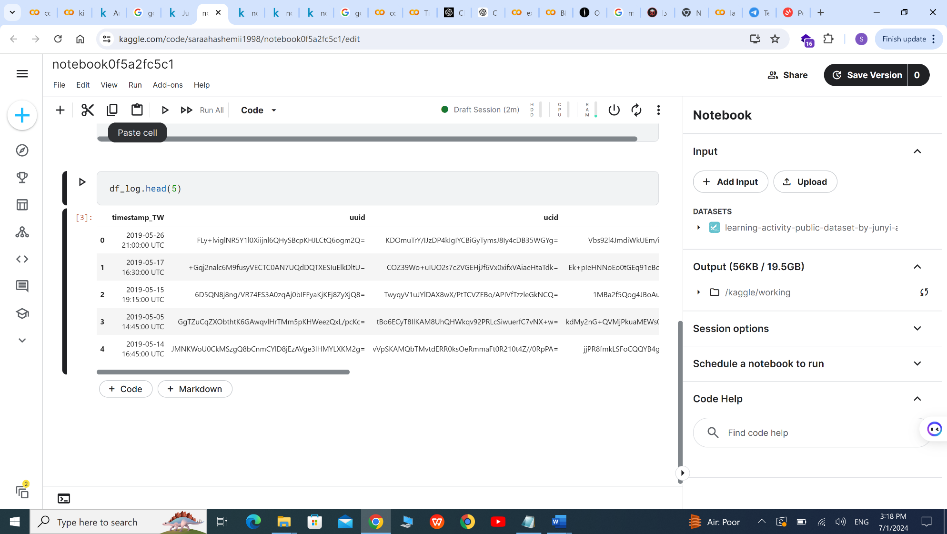

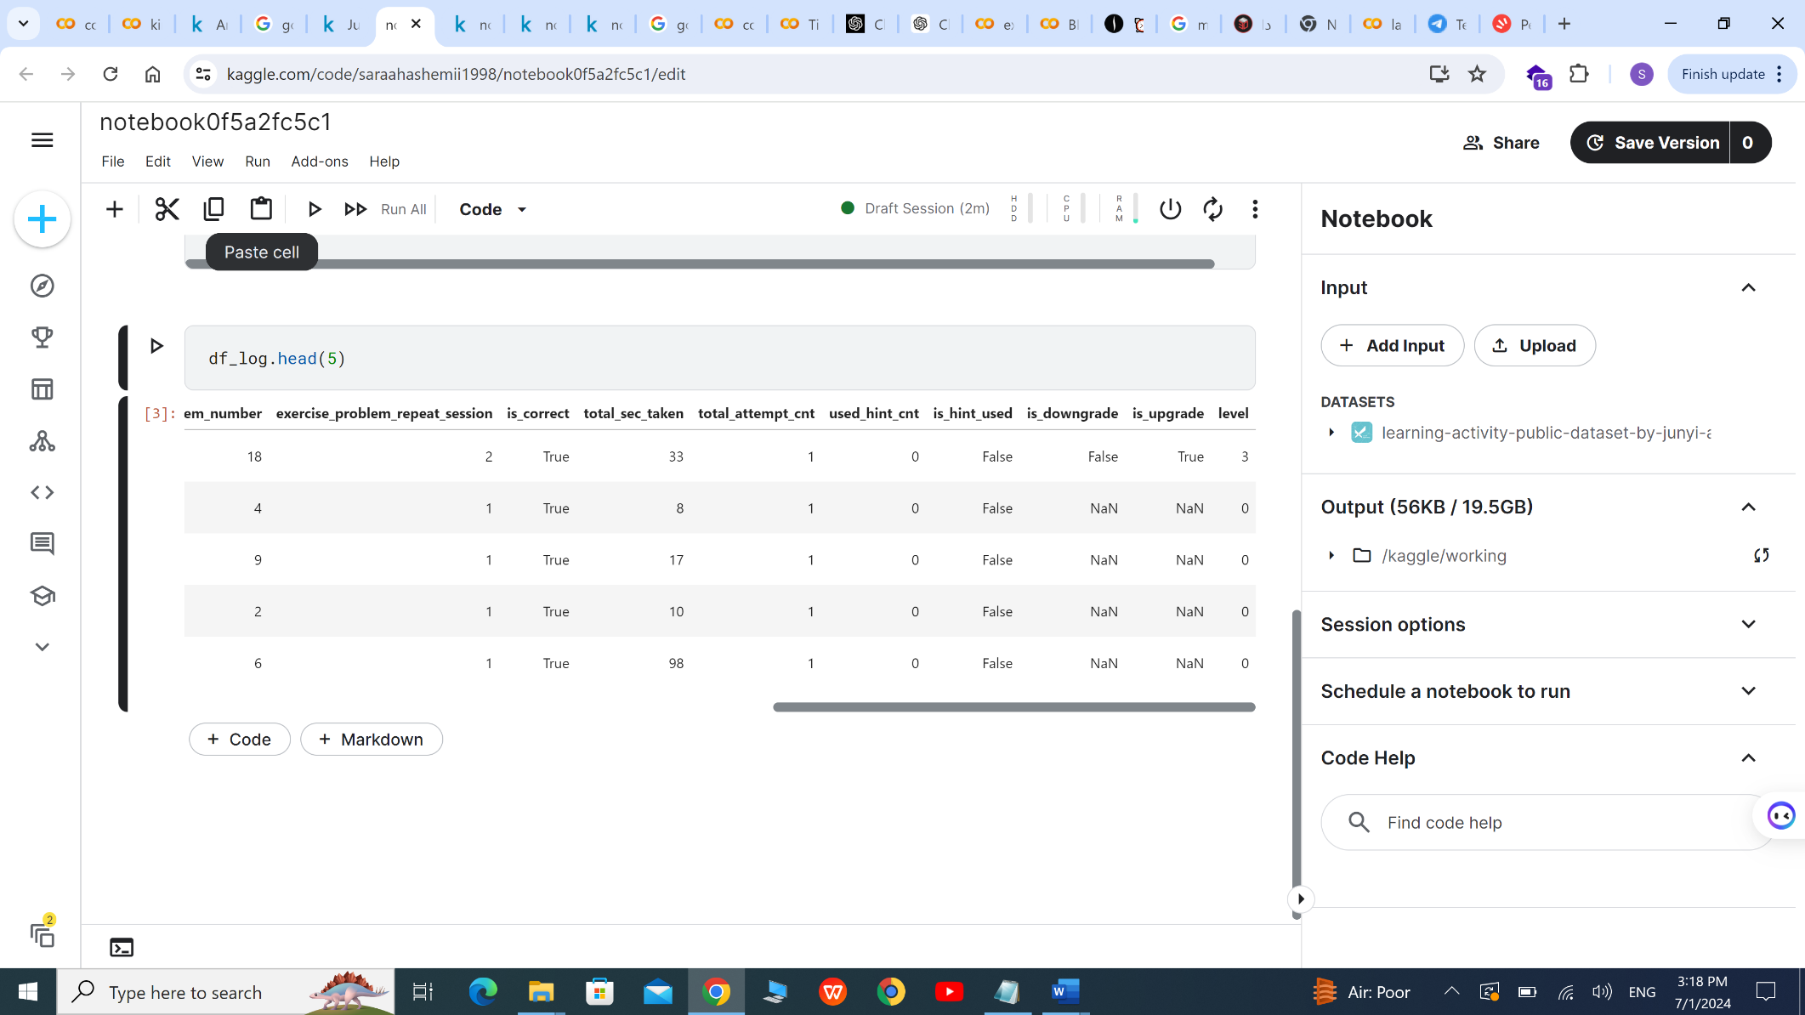

**Info_userdata:**

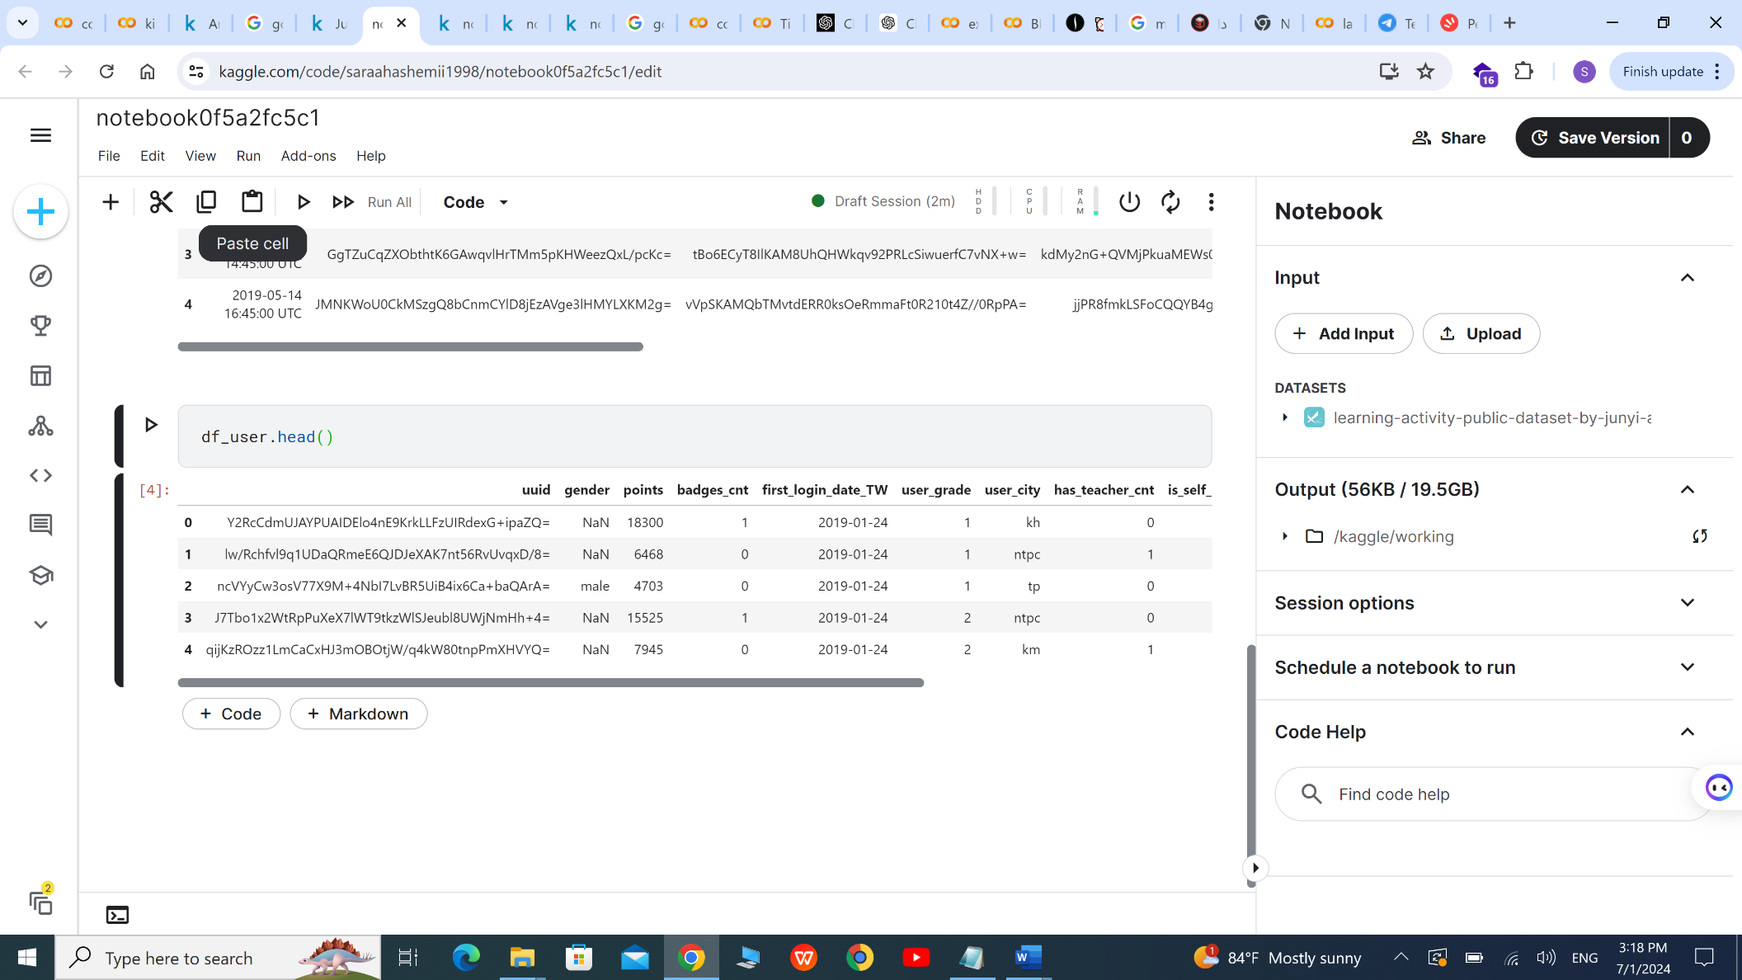

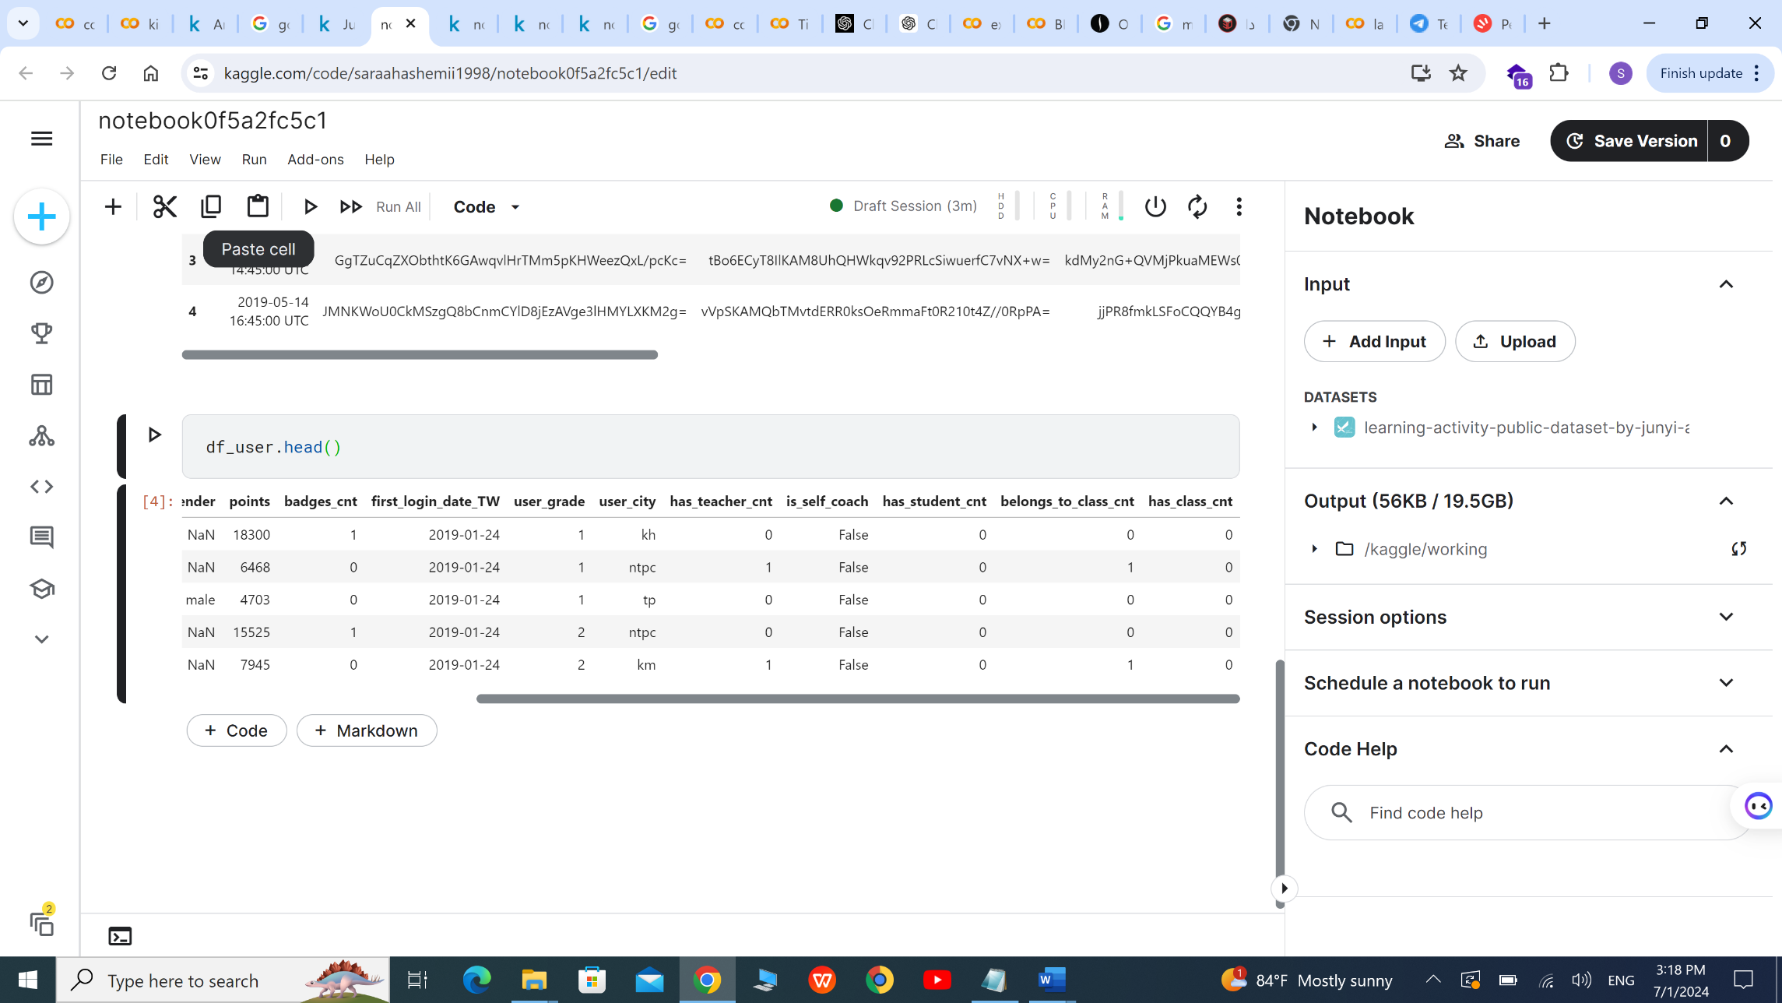

**Info_content:**

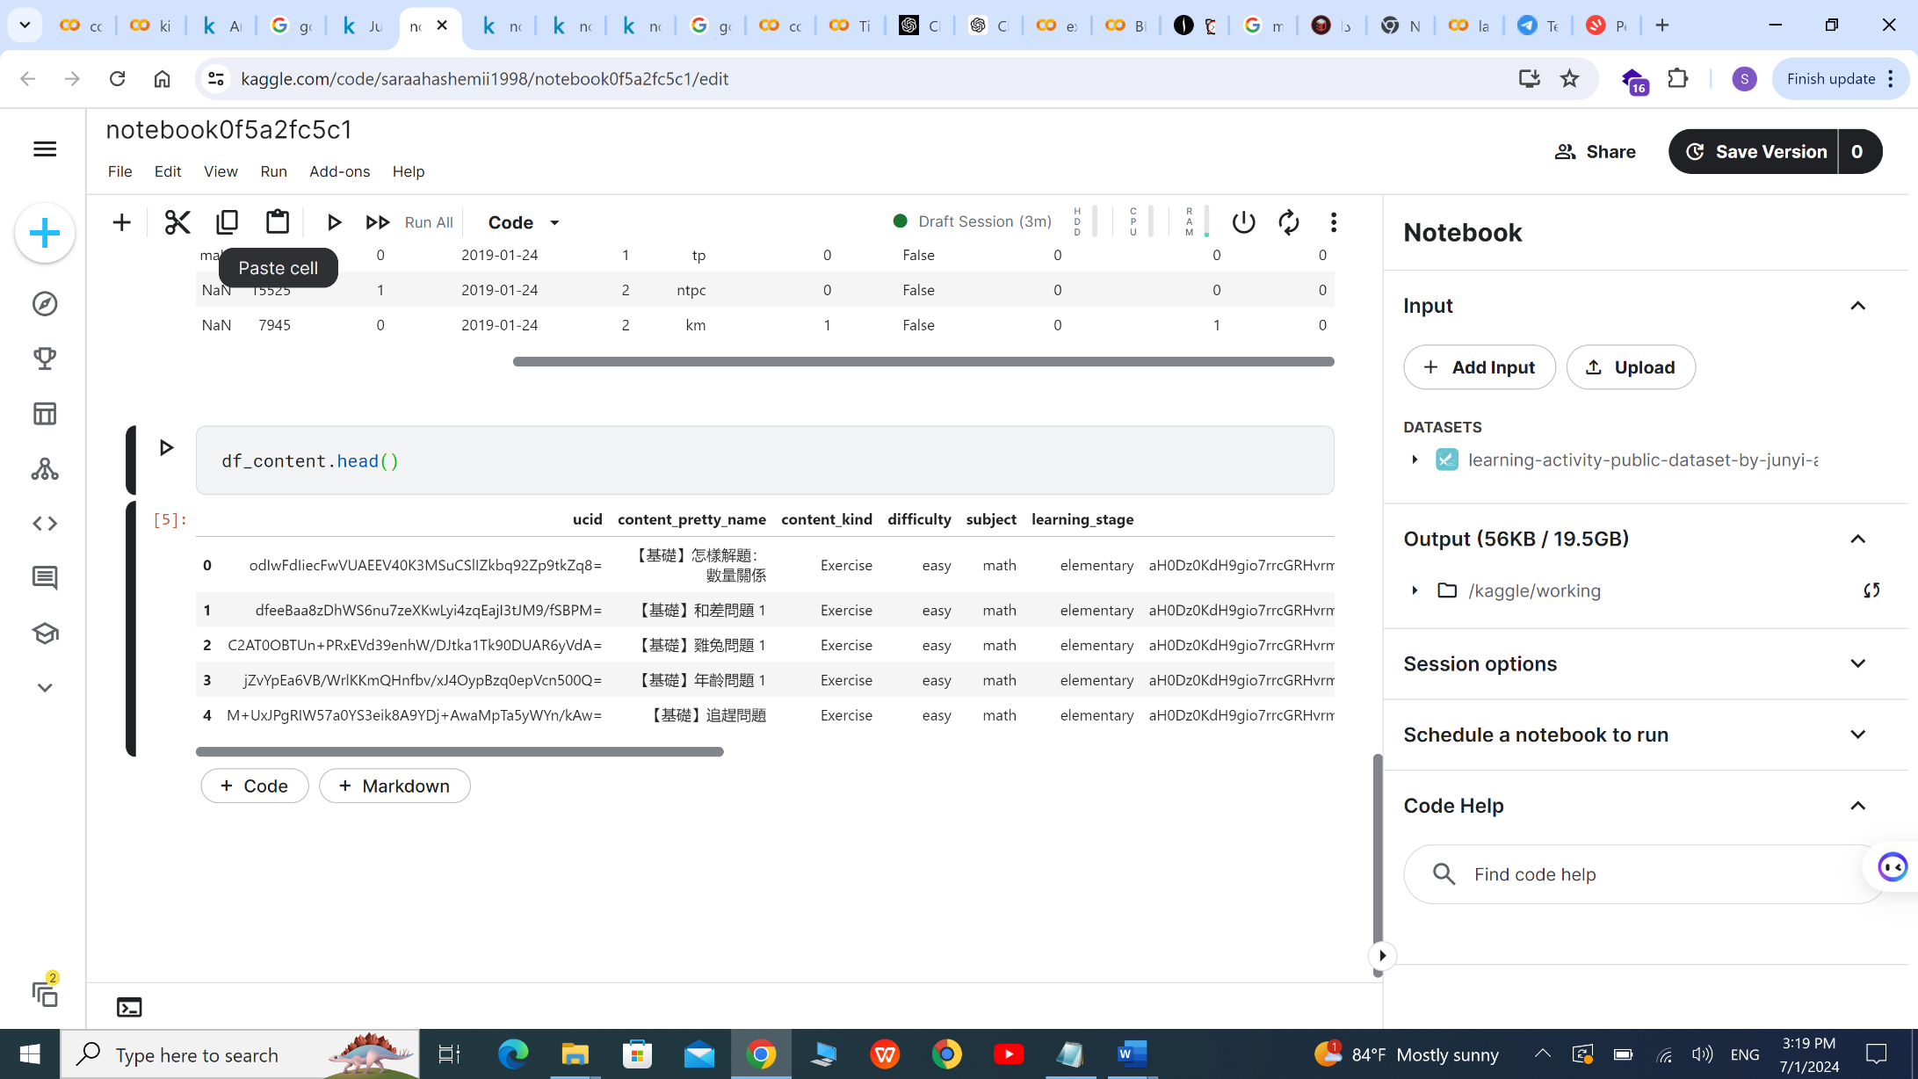

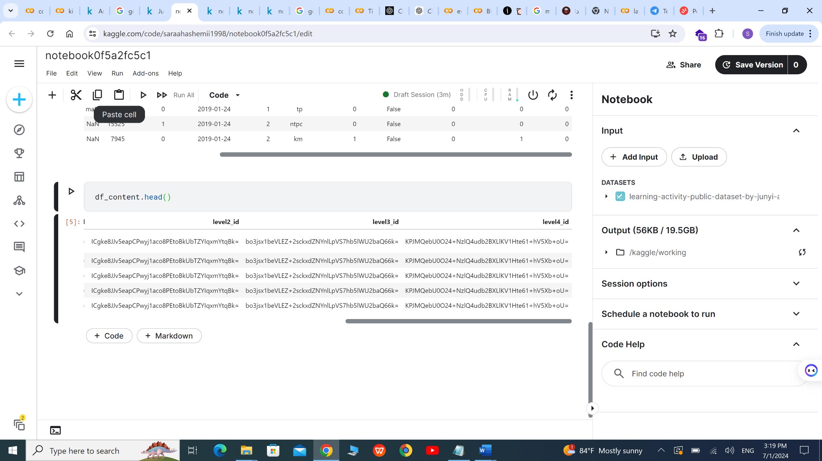

**Number of users by their gender**

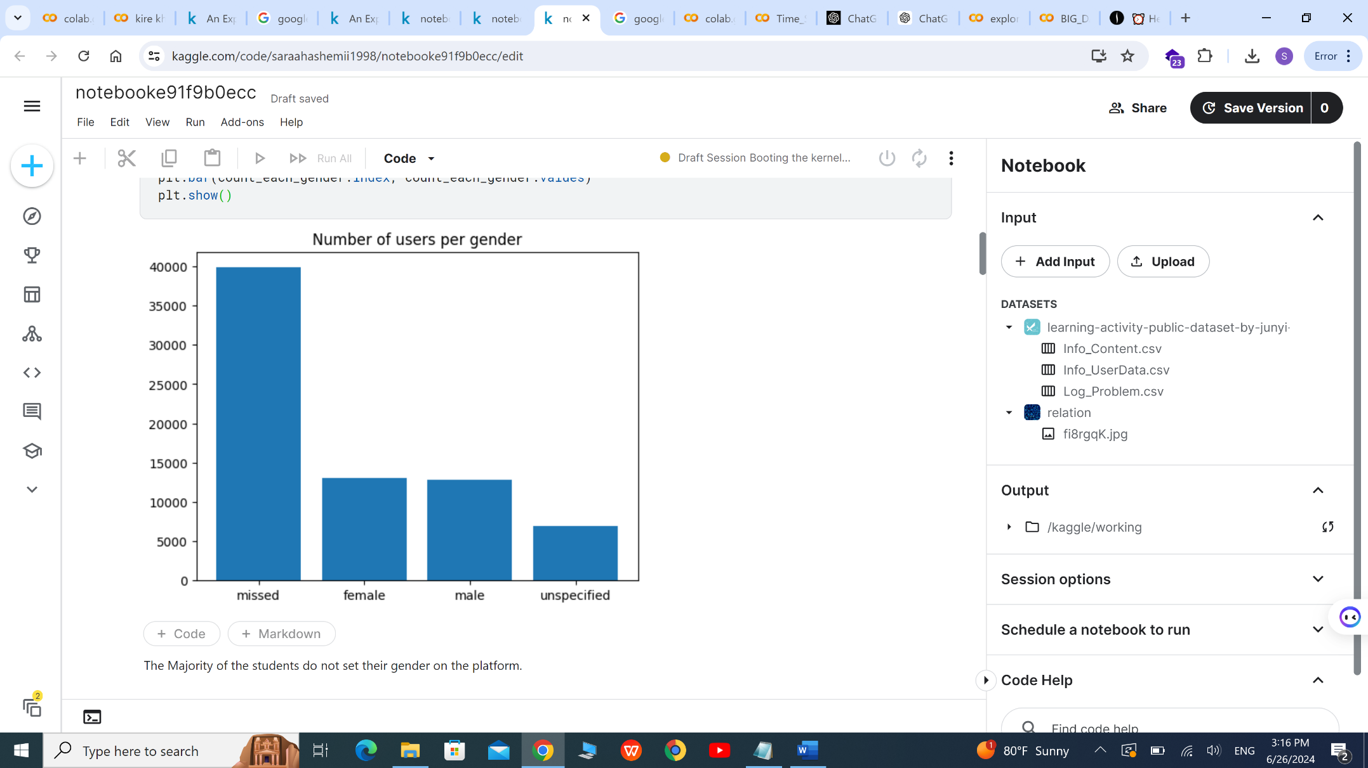

The Majority of the students do not set their gender on the platform.

**What do "problem number" and "exercise_problem_repeat_session" mean?**

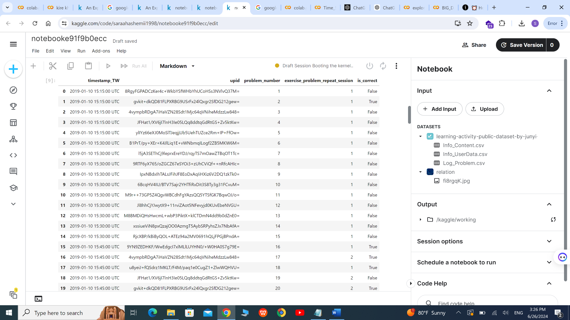

Observing the table, we can conclude that:

1. "problem number" is the problem order in the exercise for the user

2. "exercise_problem_repeat_session" is how many times the user encounter this problem

3. The timestamp is rounded to the nearest 15 minute interval to preserve privacy in the dataset

**What does energy point mean?**

Energy points are like experience points in games.  
Similar to game-based learning, users will try to learn to earn more energy points.  
Energy Points are earned from Junyi Academy after completing exercises, watching videos, and when the user receives a badge.

1. A user earns 750 * (effective watching time / video length) energy points after watching a video. (Effective watching time for a 10-minute video at 2X speed will be only 5-minute)
2. A user earns a base of 75 energy points after completing an exercise at level 0.
3. This might increase to at most 225 due to fast answering speed or repeated correct attempts.
4. The points earned will decrease to as few as 5 as the user's level of that exercise increase to encourage the user to practice other exercises.
5. Users will earn points from badges, which encourage students to keep learning and complete certain targets to earn the different badges.

**What does level mean?**

There are five possible levels, all users start from level 0 and progress to level 4 which we considered Proficient for that exercise.  
The rules are as the following for each exercise:

1. Every user starts at level 0.
2. To reach level 1, the user will have to answer the problems correctly 5 times in the recent 6 problems in the exercise.
3. To reach next level, the user needs to wait some hours, which will be longer if user is at higher level, and will answer 2 problems from the exercise. For example, the user is at level 2 and get a chance to answer 2 problems:  
   * If both are correct, the user is upgraded to level 3.
   * If both are incorrect, the user is downgraded to level 1.
   * If one of them is correct and one of them is incorrect, the level is unchanged and the user is prompted to try again the challenge.

**Top five cities where students are from**



**The relation between levels, exercise and problem.**

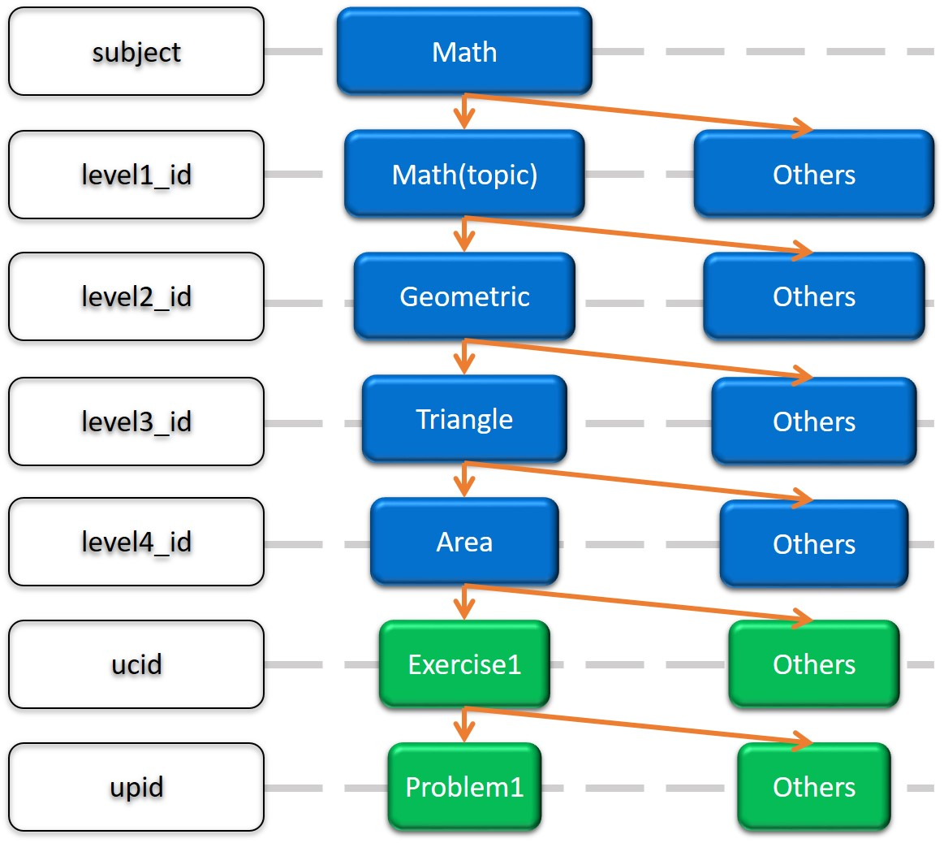

**Impact of Academic Calendar and Holidays on User Login Trends in junyi academy**

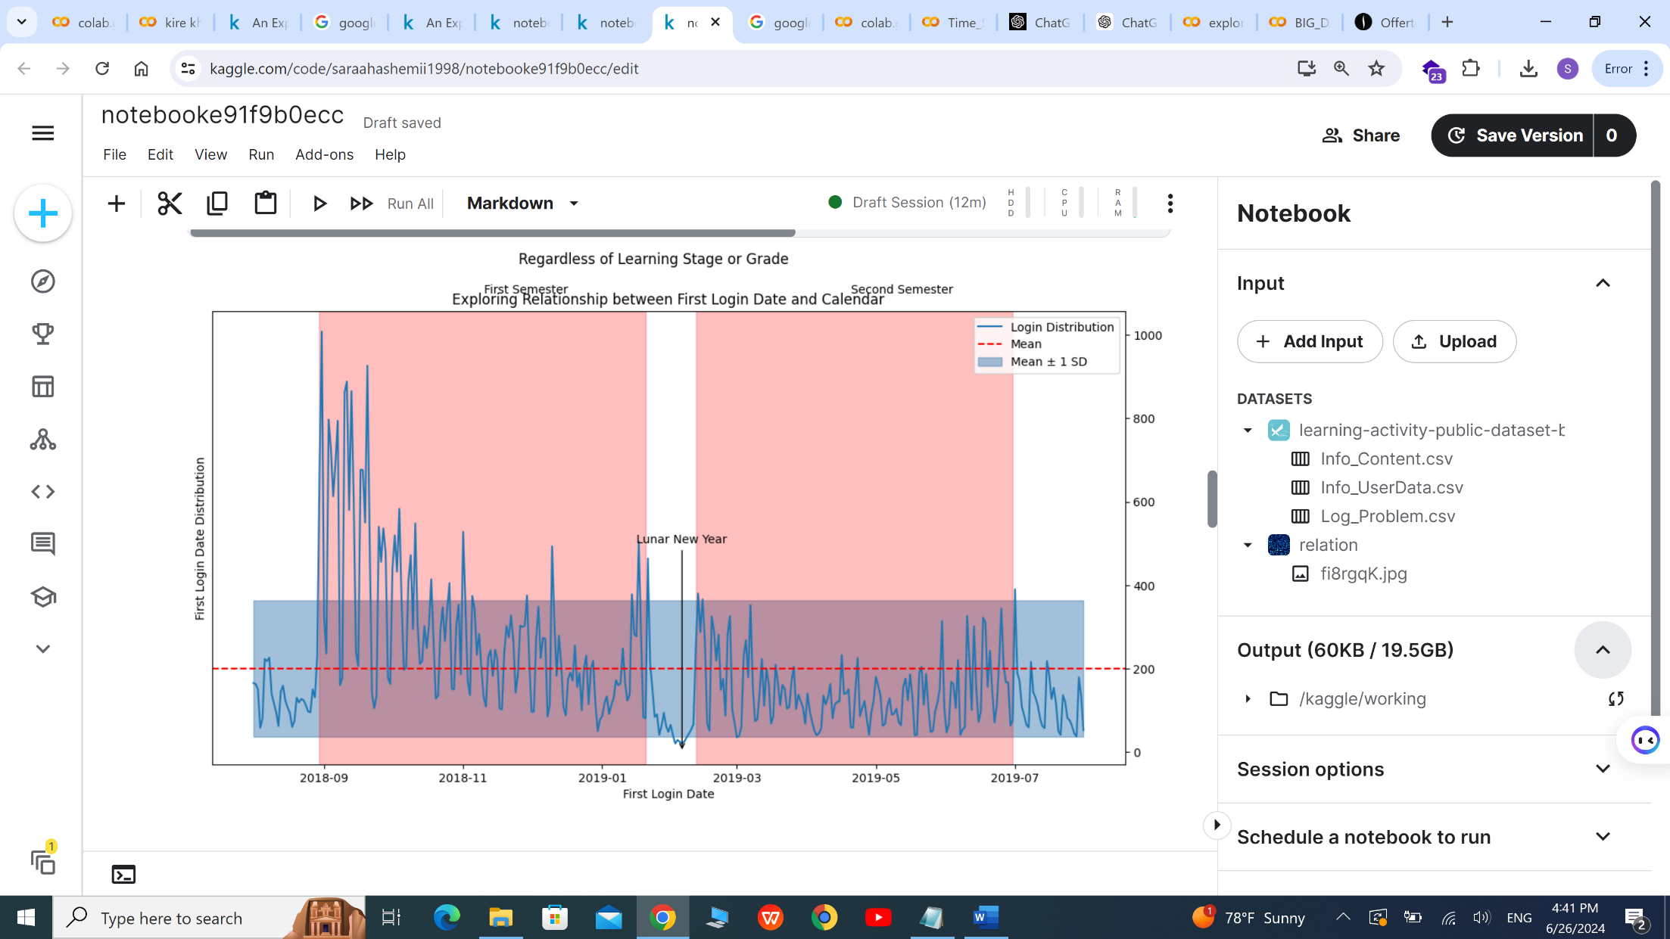

Reference the first login date (first_login_date_TW). We observed a trend showing a surge at the beginning of the semester and the start of holidays.

The highest activity occurred on August 31, 2018, the second day of the fall semester. The lowest activity was on February 5, 2019, the third day of the Lunar New Year, with the top five lowest values ranging from New Year's Eve to the fourth day of the Lunar New Year.

**Impact of Academic Calendar on Student Motivation and Retention in Exercise Programs: A Cohort Analysis**

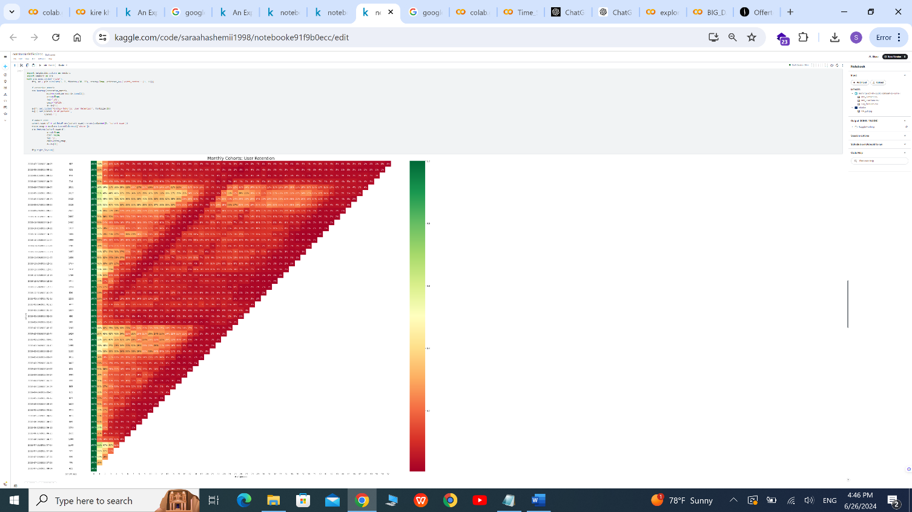

You can see the heat map plot more clear on the colab notebook.

Based on cohort analysis, retention rate of user doing exercise increasing in September and February

Based on Taiwan academic calender, we can notice that:

the first day of school is 30 August (after summer holiday)

winter holiday is 10 february - 16 february

source: https://publicholidays.tw/school-holidays/

We can conclude that student more motivated to learn on this platform after holiday and less motivated and getting bored few week after holiday.

**Distribution of exercises by their difficulties**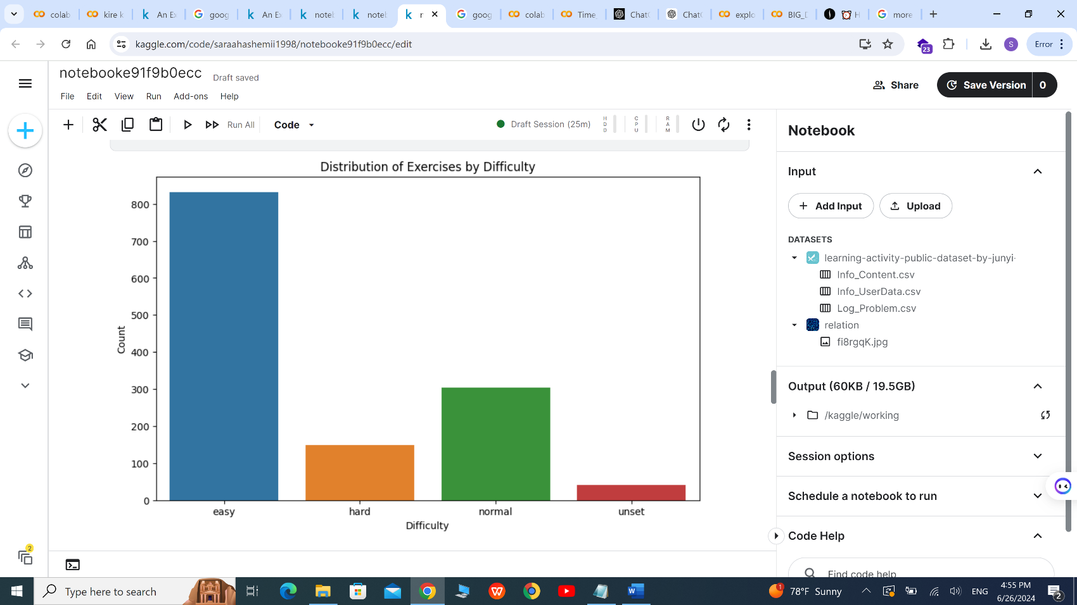

**Analyzing Problem-Solving Patterns in Exercises**



We can observe a peak in the plots, most users do 5 or 6 problems in the exercise.

This is mainly due to the proficiency mechanism, users would usually want to upgrade to level 1 and move onto the next exercise**.**

**Analyzing Active Duration on junyi academy**

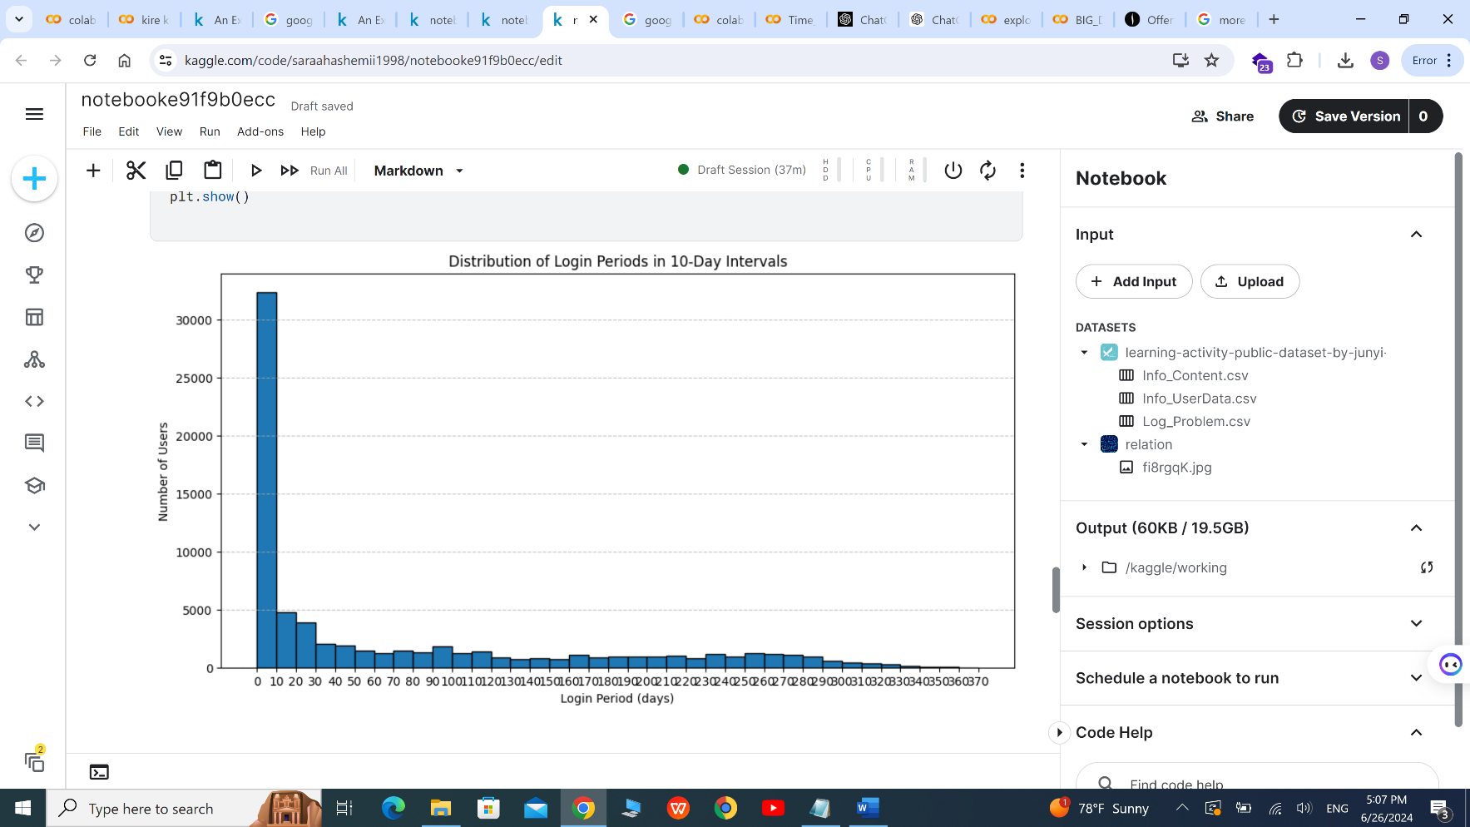

the histogram shows how long users tend to stay engaged with the site and how long users remain active on a website.as we observe in diagram above 30000 students activated in 10 days. that shows around 40% of students did not tend to continue this platform.

**Investigating the Relationship Between Problem Difficulty and Time Spent**

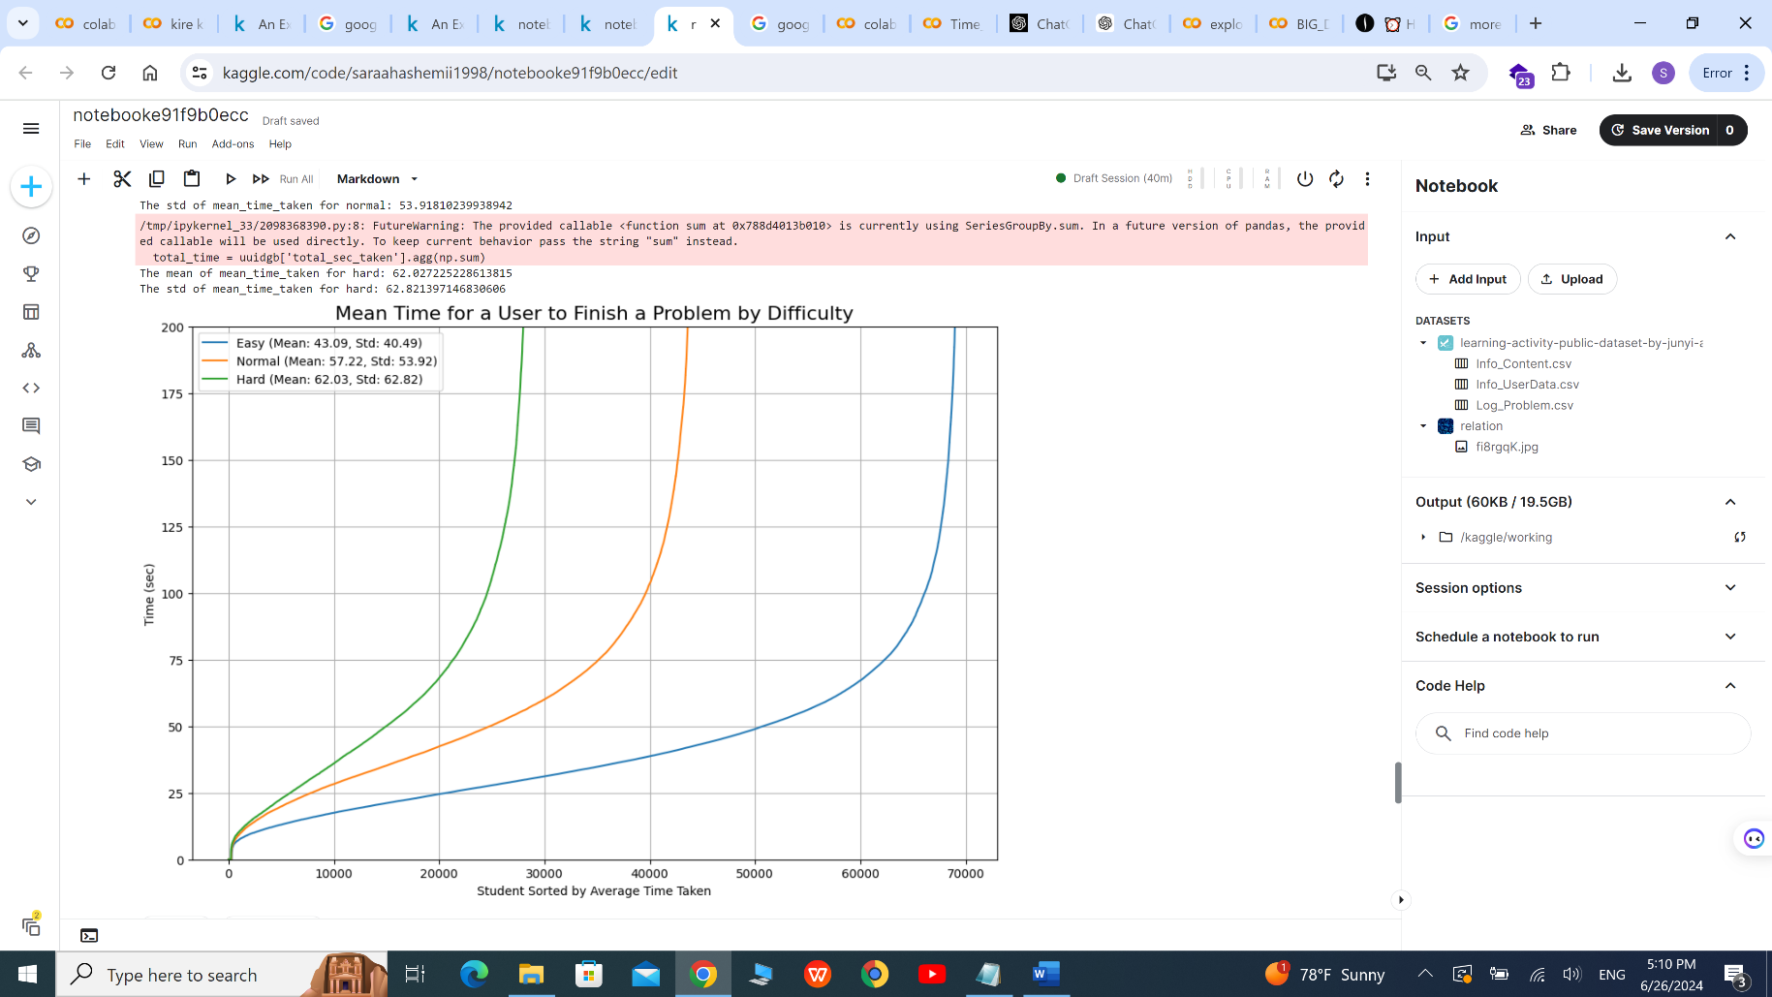

we calculate the total time spent divided by the total number of problems attempted, it shows mean of time for user to finish the problem.as green line shows,More students need more time to solve hard problems but in easy problems the line grows smoothly. if we compare the tree lines , we can observed 60000 students need up to 50 seconds to solve easy problems but in normal problems around 30000 students need this time.in hard problems about 20000 students need up to 50 seconds to solve questions.

**The Relationship Between Problem Difficulty and Correct Answer Rates**

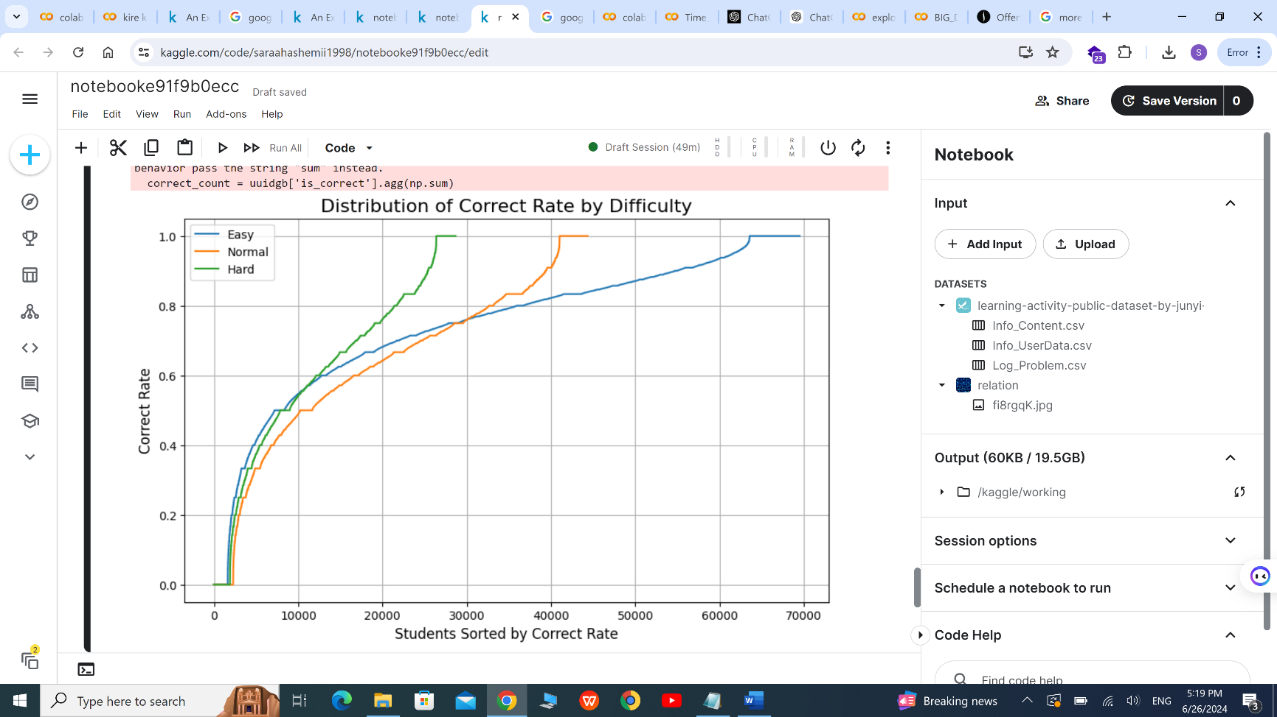

we calculate the sum of correct answers and the total number of attempted.so we can measure the correct rate by dividing these two. The lines on the graph indicate that students generally have higher correct rates on easy problems. The distribution shows that as the difficulty increases, the correct rate decreases for most students.For easy problems, the curve is smoother and gradually increases, indicating less variability in correct rates among students. For hard problems, the curve is steeper in places, showing more variability and indicating that some students perform much better than others.

**Temporal Patterns of User Engagement on junyi academy: Analyzing Hourly, Weekly, and Monthly Activity Trends**

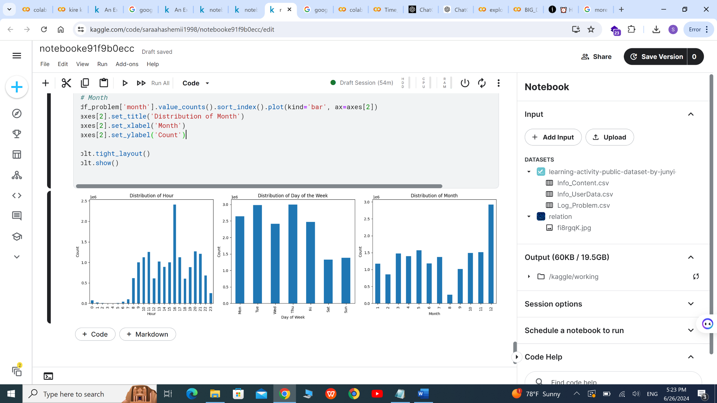

The plots show the distribution of using junyi academy, as we observe the peak of usage is at 4 p.m. , Tuesday and Thursday and the last month have been used the most.

**Implementation of models**

We choose two time series models to run on our dataset (LSTM,SARIMAX),our target variable is the number of login in the junyi academy website.

As it shows, first we make a table which count amount of logins per days.

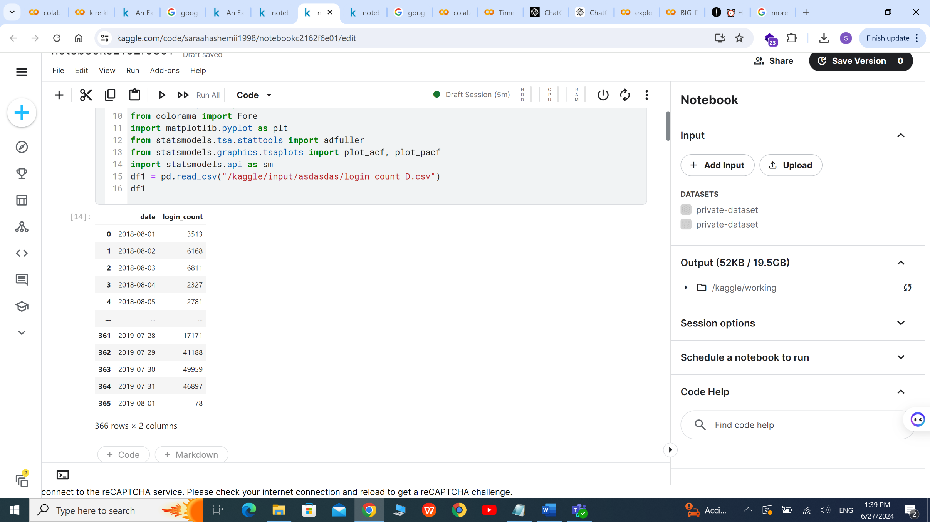

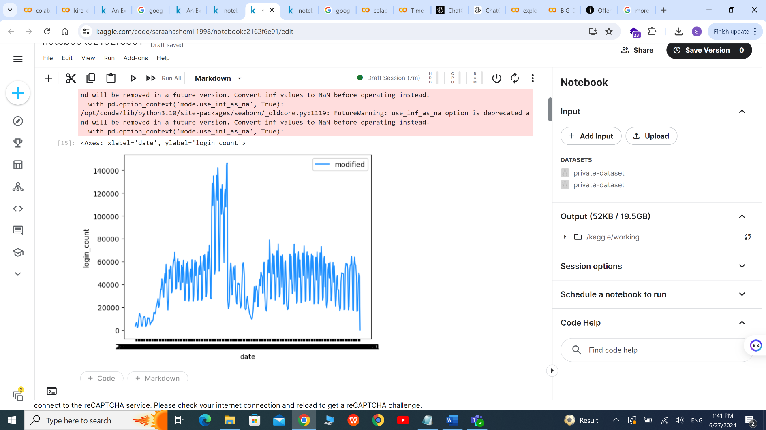

The line plot represent the login counts in a year. the x-axis represents dates, and the y-axis represents login counts. The plot shows a sharp increase in login counts initially, indicating a period of high activity or user engagement. After the initial rise, there is noticeable variability in the login counts, indicating fluctuating user activity.

**Using Log Transformations and the Augmented Dickey-Fuller (ADF) Test to Assess Time Series Stationarity**

Log transformations are often used to stabilize the variance of a time series and to make it more normally distributed. Also the ADF test is used to check whether a time series is stationary or has a unit root (i.e., is non-stationary).

In this analysis, the ADF test was applied to the log-transformed time series data to assess its stationarity. The results of the ADF test are as follows:

* *Test Statistic*: -1.6759213947969376
* *p-value*: 0.44355923860017904
* *Number of Lags Used: 7*
* *Number of Observations*: 358

The p-value (0.44355923860017904) indicates the probability of observing the test statistic under the null hypothesis (that the series has a unit root, i.e., is non-stationary). A higher p-value suggests weaker evidence against stationarity.

**Assessing Time Series Stationarity Using Differencing and the Augmented Dickey-Fuller (ADF) Test**

Differencing is a common technique used to transform a non-stationary time series into a stationary one. This technique calculates the differences between consecutive observations, effectively removing trends and stabilizing the mean of the series.

In this analysis, the first difference of the login_count column was calculated to address its non-stationarity. To verify the effectiveness of this transformation, the Augmented Dickey-Fuller (ADF) test was applied to the differenced series. The results of the ADF test are as follows:

* *Test Statistic*: -5.189843811972838
* *p-value*: 9.221691961925547e-06
* *Number of Lags Used*: 13
* *Number of Observations*: 351

The **p-value** (9.221691961925547e-06) is extremely small, indicating strong evidence against the null hypothesis (that the series has a unit root, i.e., is non-stationary). Typically, we reject the null hypothesis when the p-value is below a chosen significance level (e.g., 0.05). In this case, the p-value is significantly below 0.05, allowing us to confidently reject the null hypothesis and conclude that the differenced series is stationary.

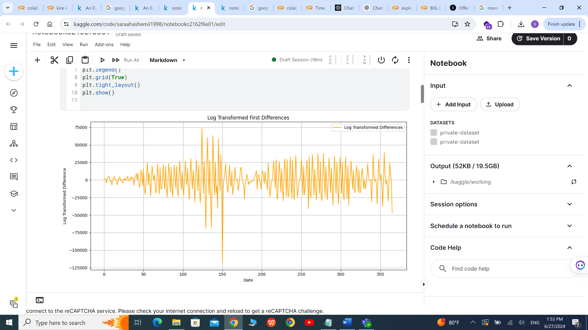

The graph shows log-transformed differences over time. Peaks represent high positive differences, while troughs represent low negative differences. The large gap between the maximum and minimum values suggests substantial variation.

**Achieving Stationarity through Log Differencing and ADF Testing in Time Series Analysis**

In time series analysis, achieving stationarity is crucial for building robust forecasting models. One effective method to stabilize both the variance and mean of a series is by calculating the first differences of log-transformed values. This technique was applied to the login_count column in our dataset.

To confirm that the log-differenced series is stationary, we applied the Augmented Dickey-Fuller (ADF) test. The test yielded the following results:

* **p-value**: 0.0005584747014459555

The **p-value** (0.0005584747014459555) is significantly less than the chosen significance level (0.05), indicating strong evidence against the null hypothesis of non-stationarity. As a result, we reject the null hypothesis and conclude that the log-differenced login_count series is stationary.

**Visualizing Stationarity with Log-Transformed First Differences and ADF Testing**

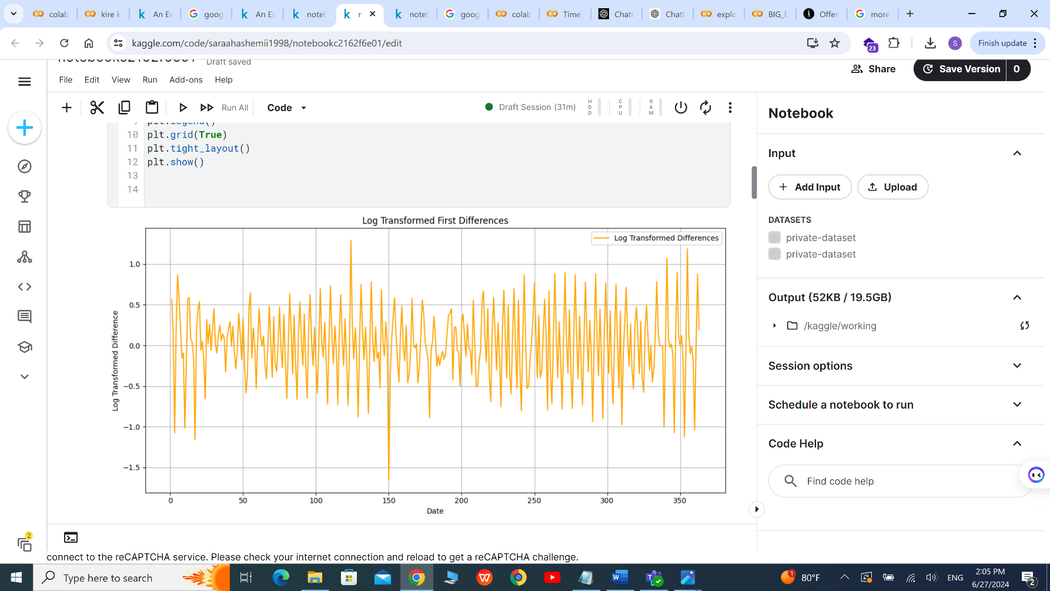

Log Transformed First Differences" indicates that the plot shows the first differences of the log-transformed data. X-axis (Date): Represents the time or date over the period of the dataset. Y-axis (Log Transformed Difference): Represents the difference between consecutive log-transformed values of login_countThe orange line represents the log-transformed differences over time. Each point on the line is the difference between the log-transformed value of login_count at time t and time t−1.The plot of log-transformed first differences shows that the series appears to be stationary, fluctuating around a mean close to zero without obvious trends or seasonality. The ADF test result supports this visual observation, confirming that the differenced series does not have a unit root and is stationary.

**Understanding Autocorrelation Function (ACF) and Partial Autocorrelation Function (PACF) in Time Series Analysis**

In time series analysis, Autocorrelation Function (ACF) and Partial Autocorrelation Function (PACF) are essential tools for understanding the properties of the data and identifying the appropriate models for forecasting.

**Autocorrelation Function (ACF)**

The ACF measures the correlation between a time series and lagged versions of itself. It helps in identifying the strength and direction of the relationship between the values of the series at different time lags.

* **Definition**: ACF at lag k is the correlation between the series values and their lagged counterparts k time points apart.
* **Interpretation**: A high ACF value at a specific lag indicates a strong relationship between the series values at that lag. It includes both direct and indirect effects of past data points.

For example, ACF at lag 2 would compare the series with its own values shifted by two time points, capturing both direct correlations (at lag 2) and indirect correlations through lag 1.

**Partial Autocorrelation Function (PACF)**

The PACF measures the correlation between a time series and lagged versions of itself, but after eliminating the variations explained by the intervening lags. This provides a clearer picture of the direct relationship between the series values and their specific lags.

* **Definition**: PACF at lag kkk is the correlation between the series and its lagged version k time points back, after removing the effects of lags 1,2,...,k−11, 2, ..., k-11,2,...,k−1.
* **Interpretation**: PACF helps in identifying the order of the autoregressive (AR) part of an ARIMA model by showing the direct influence of past values on the current value.

For example, PACF at lag 2 measures the correlation between the series and its lagged version two time points back, but after accounting for the effects of lag 1.

Here the plots of our ACF and PACF:

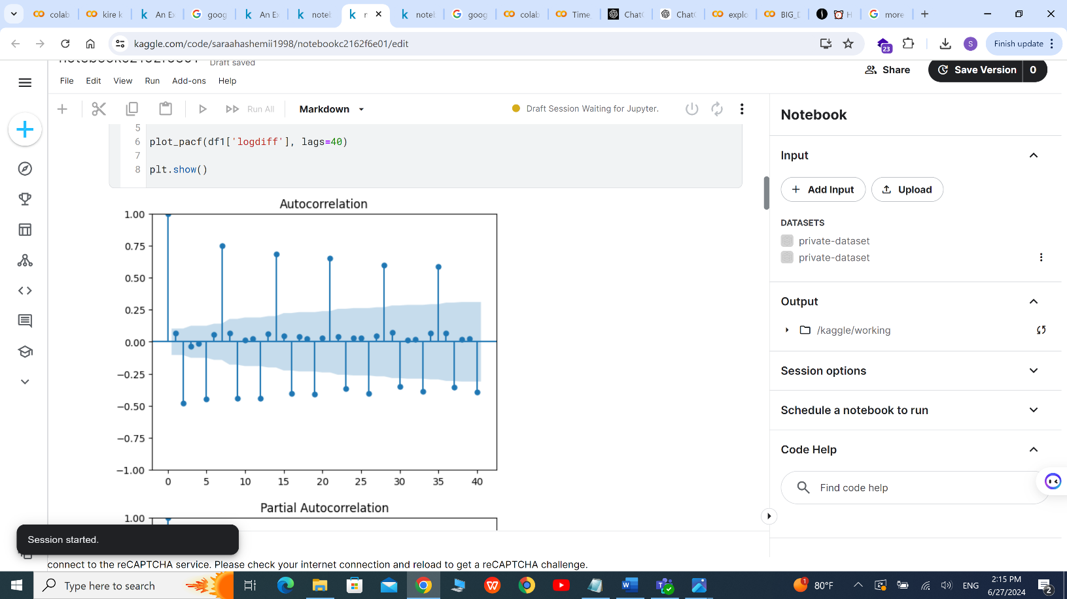 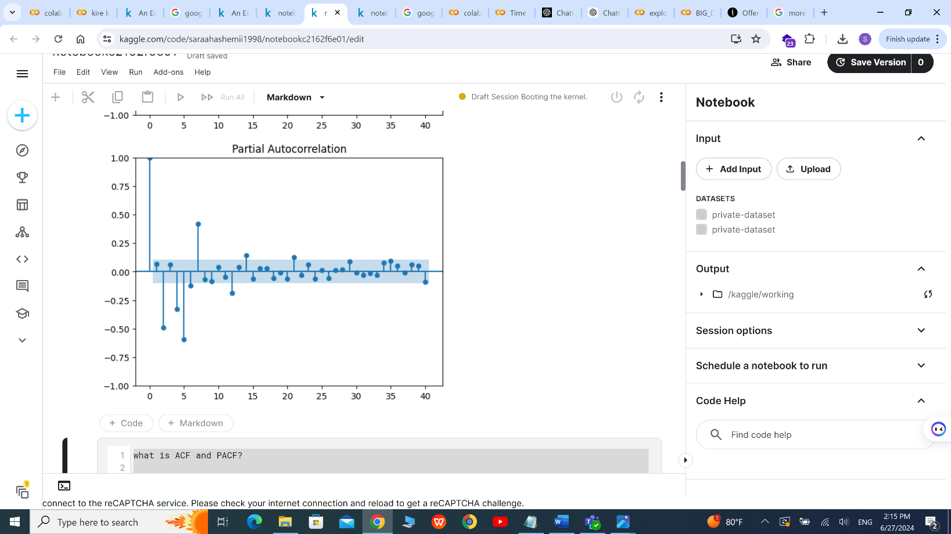

**Automatic ARIMA Model Selection with pm.auto_arima in Time Series Analysis**

In time series analysis, selecting the optimal model is crucial for accurate forecasting. The pm.auto_arima() function from the pmdarima library automates this process by evaluating various combinations of AR (Auto-Regressive) and MA (Moving Average) orders to identify the best-fitting model for a given time series.

The code leverages pm.auto_arima() to automatically determine the most suitable ARIMA model for the time series y_train. The function systematically tests different configurations of AR and MA terms and evaluates their performance to select the optimal model.

The optimal model identified by pm.auto_arima() is ARIMA(0,0,0), which indicates this model does not include any Auto-Regressive (AR) or Moving Average (MA) terms and is essentially a constant with an intercept.

**Optimizing SARIMA Model Parameters Using a Brute-Force Approach in Time Series Forecasting**

In time series forecasting, finding the optimal combination of parameters for a Seasonal Autoregressive Integrated Moving Average (SARIMA) model is essential for accurate predictions. This code employs a brute-force approach to identify the best SARIMA parameters by systematically evaluating different configurations.

The goal of this code is to find the best combination of parameters for a Seasonal Autoregressive Integrated Moving Average (SARIMA) model using a brute-force approach. It iterates through various combinations of SARIMA hyperparameters and evaluates their performance. Parameter Combinations: The code loops through different values of the following parameters: p, i, and q: The non-seasonal AR, differencing, and MA orders. P, D, and Q: The seasonal AR, seasonal differencing, and seasonal MA orders. The seasonal period is set to 7 days (seasonal_order=(P, D, Q, 7)). Model Fitting and Scoring: For each parameter combination, it initializes and fits a SARIMAX model to the training data (train). The model is configured with the specified orders and other settings (e.g., enforce_stationarity, enforce_invertibility). It then forecasts the test data (test) and computes the R-squared score to evaluate model performance.

**Visualizing SARIMA Model Forecasting and Evaluation**

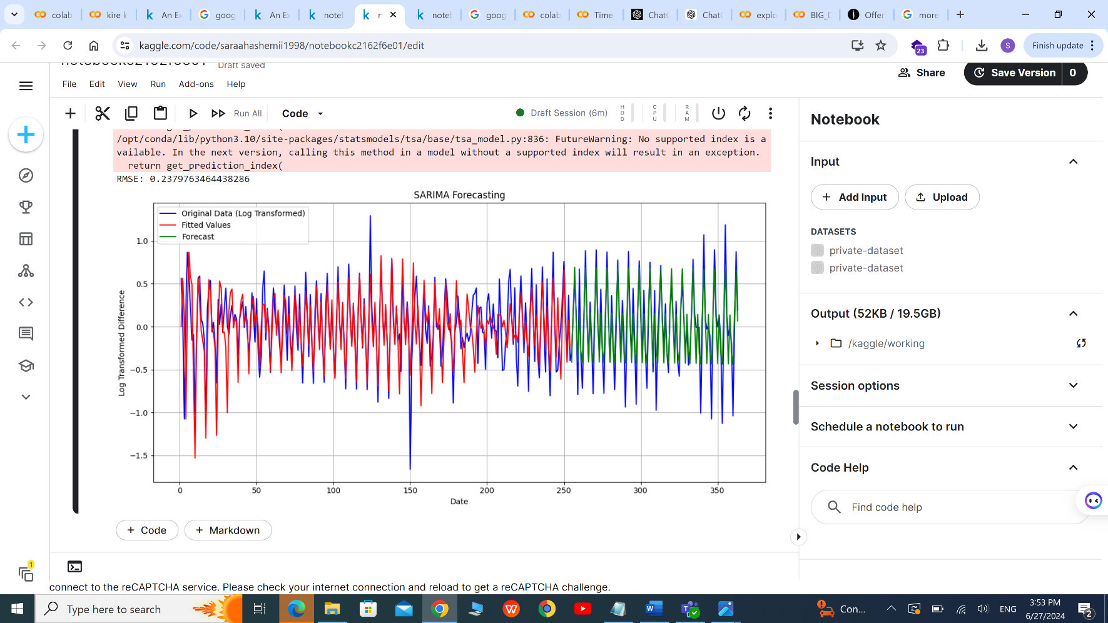

The provided plot illustrates the process and results of fitting a Seasonal Autoregressive Integrated Moving Average (SARIMA) model to a time series dataset, followed by forecasting future values and evaluating the model's performance.

After fitting the model, the forecast variable stores the predicted values for the test dataset . The length of the forecast matches the length of the test set, providing a direct comparison between actual and predicted values.

The plot and accompanying code demonstrate the application of a SARIMA model for time series forecasting. By visualizing the original data, fitted values, and forecasted values, along with evaluating the model’s performance using RMSE, Root Mean Squared Error (RMSE): The RMSE is calculated to evaluate the model’s performance. It measures the average difference between the predicted and actual values. Lower RMSE indicates better performance.

MAE: 0.17576978536911564

MSE: 0.05663274146675312

RMSE: 0.2379763464438286

In this plot. we gain insights into the effectiveness of the SARIMA model in capturing the underlying patterns and making accurate future predictions. This approach is essential for making informed decisions based on time series data.

**Comprehensive Evaluation of SARIMA Model Forecasting with Visual and Statistical Diagnostics**

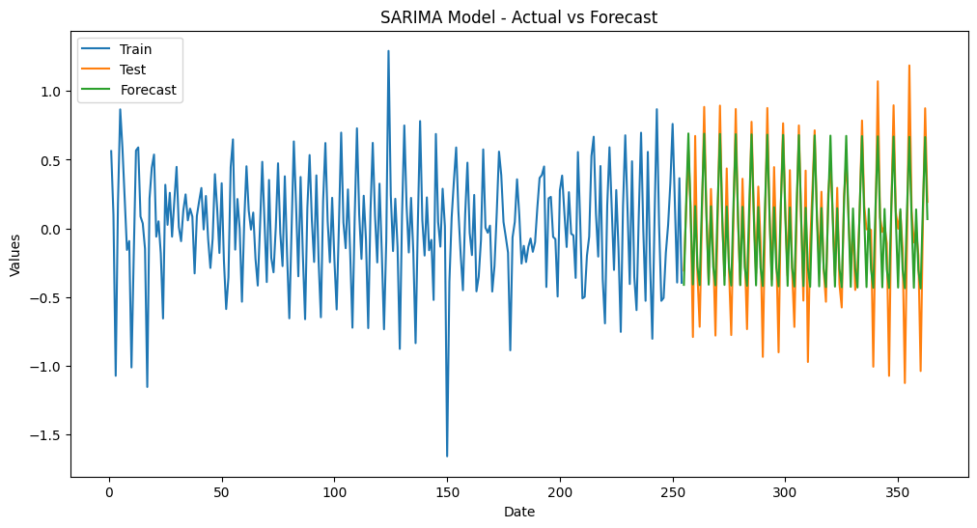

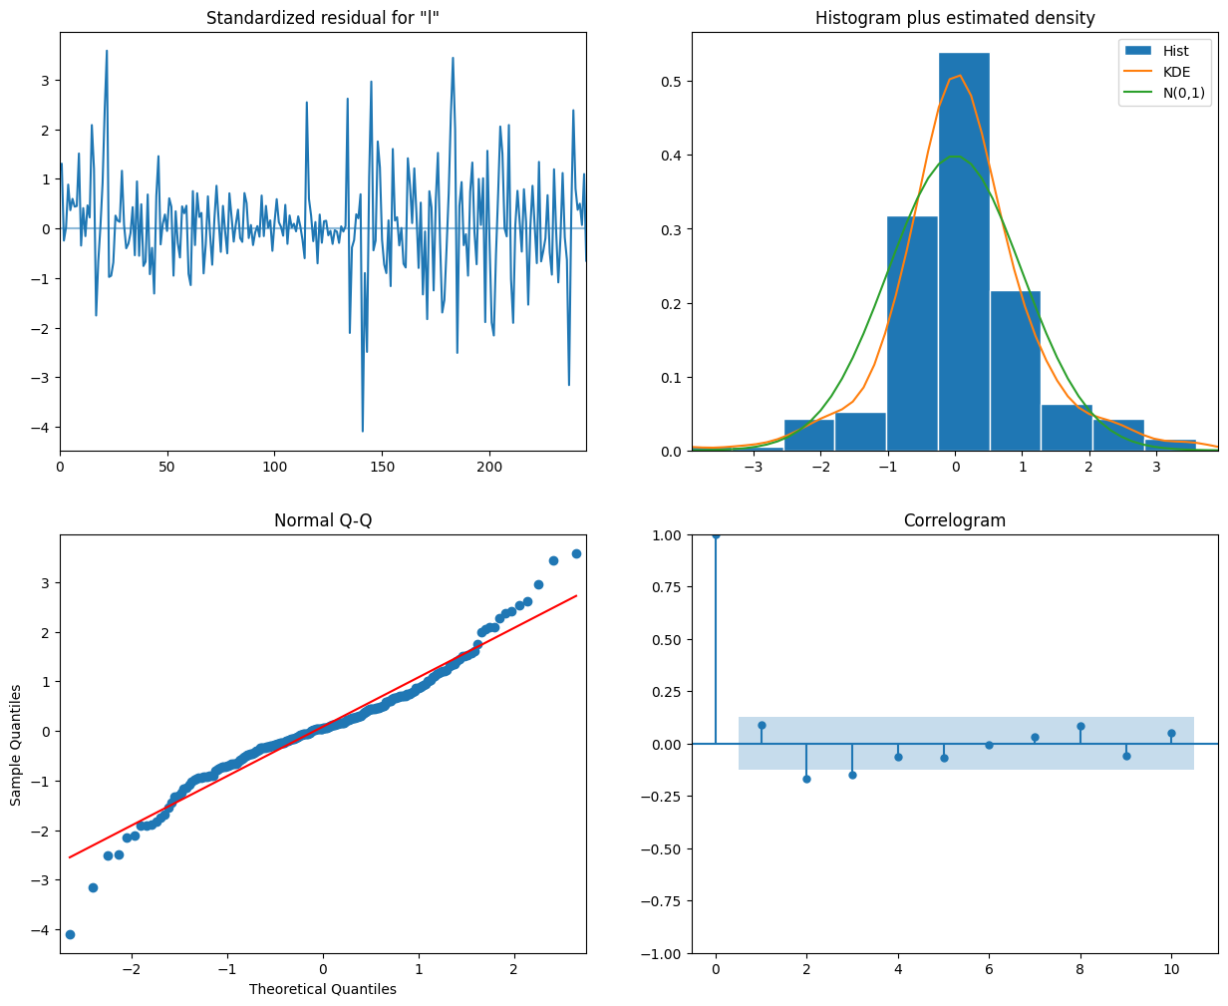

Actual vs. Predicted Values Plot: The first plot shows the actual values from the test set (Test) along with the forecasted values (Forecast) produced by the SARIMA model. It helps visualize how well the model predictions align with the actual data. Residuals Plot: The second plot displays the residuals, which are the differences between the actual values and the forecasted values. Residuals provide insights into the model’s performance and any remaining patterns or errors. Diagnostic Plots: The third set of plots (generated by model_fit.plot_diagnostics()) assesses the model’s assumptions and residuals: Top Left: Histogram of residuals (should resemble a normal distribution). Top Right: Q-Q plot (checks normality assumption). Bottom Left: Autocorrelation function (ACF) of residuals (should not show significant patterns). Bottom Right: Partial autocorrelation function (PACF) of residuals (helps identify AR and MA terms). Statistical Summary: The model_fit.summary() provides detailed information about the SARIMA model’s coefficients, standard errors, p-values, and other statistical metrics. It’s useful for understanding the significance of each parameter.

**LSTM MODEL**

the LSTM model architecture is defined using the Sequential class from Keras.

It consists of two LSTM layers with 128 and 64 units, respectively.

The final output layer has a single unit.

Model Compilation:

The model is compiled with the Adam optimizer and the mean squared error (MSE) loss function.

Model Training:

The model is trained on the training data (train_X, train_Y) with a batch size of 3 and 20 epochs.

Validation data (test_X, test_Y) is used for monitoring performance during training.

Prediction and Inversion:

The model predicts values for both training and test data.

Predictions are inverted using the separate target scaler to obtain original scale values.

Evaluation Metrics:

The root mean squared error (RMSE) and mean absolute error (MAE) are calculated to assess model performance.

RMSE: 0.3587078733959657

MAE: 0.2896473026490036

MSE: 0.12867133843625617

**Visualizing Forecast Performance: Actual vs Predicted Values in Time Series Analysis**

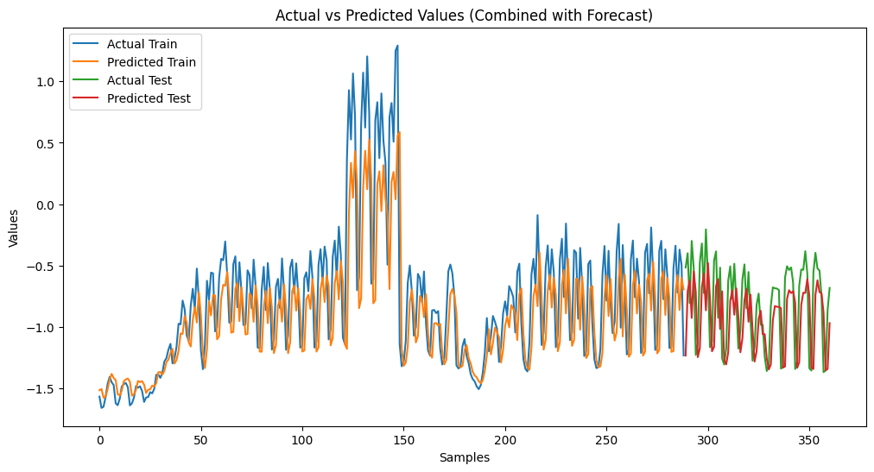

The code generates a forecast for a time series model and visualizes the results along with the actual values. Here's a breakdown of the output you can expect:

A single plot will be generated showing all the data and predictions together.

It will include lines for:

Actual and predicted values for the training set

Actual and predicted values for the test set (Commented out in the code) The 12-period forecast (a dashed line) - This section is commented out, so you won't see it by default.

**Evaluating Training Performance: Actual vs Predicted Values in Time Series Forecasting**

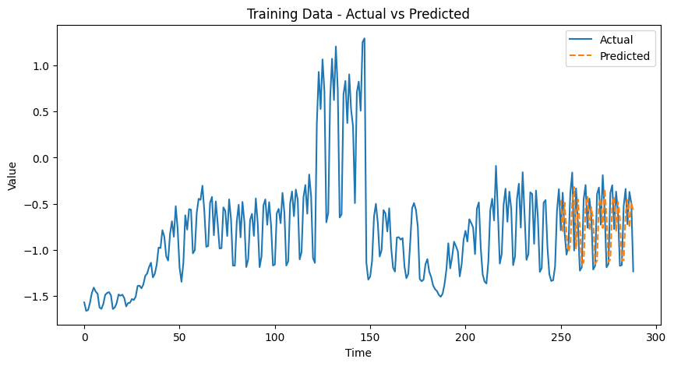

This plot illustrates the comparison between the actual values of the training data and the values predicted by the time series model.

The x-axis represents the time, while the y-axis shows the values of the time series.

**Conclusion:**

Performance Metrics SARIMA Model:

Mean Absolute Error (MAE): 0.1621 Mean Squared Error (MSE): 0.0503 Root Mean Squared Error (RMSE): 0.2243

LSTM Model:

Mean Absolute Error (MAE): 0.2659 Mean Squared Error (MSE): 0.1119 Root Mean Squared Error (RMSE): 0.3346

Analysis Mean Absolute Error (MAE):

The SARIMA model has a lower MAE (0.1621) compared to the LSTM model (0.2659). This indicates that on average, the SARIMA model's predictions are closer to the actual values than those of the LSTM model. Mean Squared Error (MSE):

The MSE for the SARIMA model (0.0503) is significantly lower than that for the LSTM model (0.1119). Since MSE penalizes larger errors more heavily, this suggests that the SARIMA model makes fewer large errors compared to the LSTM model. Root Mean Squared Error (RMSE):

The RMSE of the SARIMA model (0.2243) is also lower than that of the LSTM model (0.3346). This metric, being in the same units as the data, provides a direct comparison of the error magnitude. Again, the SARIMA model demonstrates better performance. Conclusion Based on the evaluation metrics, the SARIMA model outperforms the LSTM model in this particular forecasting task. The SARIMA model exhibits lower MAE, MSE, and RMSE values, indicating that it provides more accurate and reliable predictions.

The superior performance of the SARIMA model can be attributed to the inherent characteristics of the time series data. SARIMA is particularly effective in capturing seasonality and trends, which might be the dominant features in the dataset.

On the other hand, while LSTM models are powerful and capable of capturing complex patterns and long-term dependencies in the data, they might require more tuning and larger datasets to outperform traditional methods like SARIMA in certain scenarios.